PROJECT REPORT

1.INTRODUCTION

1.1 Overview :

A customer relationship management(CRM) software is used by businesses to manage interaction with current and future customers .Today’s CRMs have evolved into a confluence of multiple functions but the primary objective of a CRM is to serve the customers better, increase retention ,and manage the sales pipeline.

1.2 Purpose:

* CRM industry revenue is predicted to reach over$80 billion .
* Problem is, you’re here .
* Manages candidate database.
* Reduces cost per hire .
* No worries pal ,we’ve got you covered .
* Generates key recruiting insights.

2.PROBLEM DEFINION &DESING THINKING

2.1 Emphaty map :

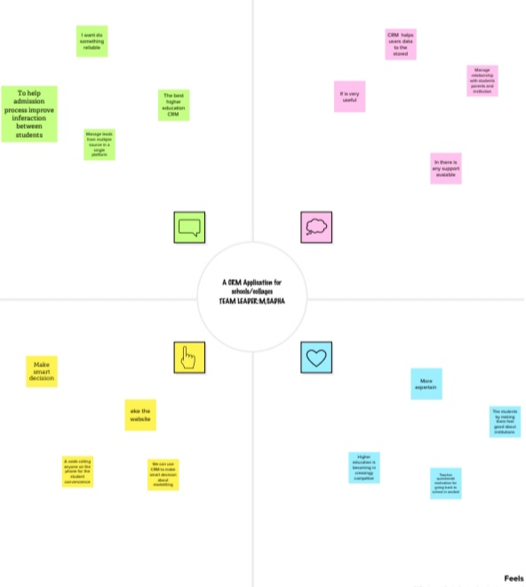

2.2 Ideation &Brainstorming Map:

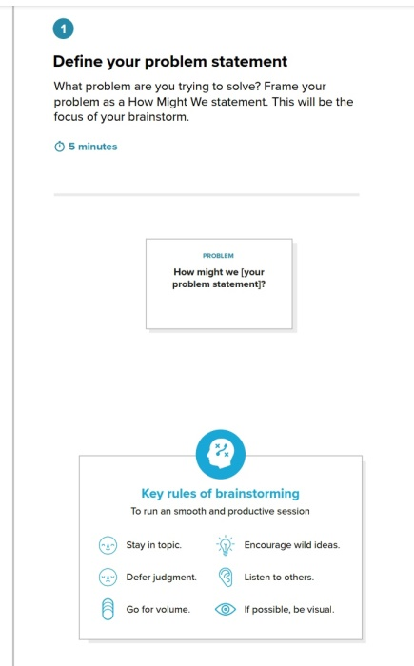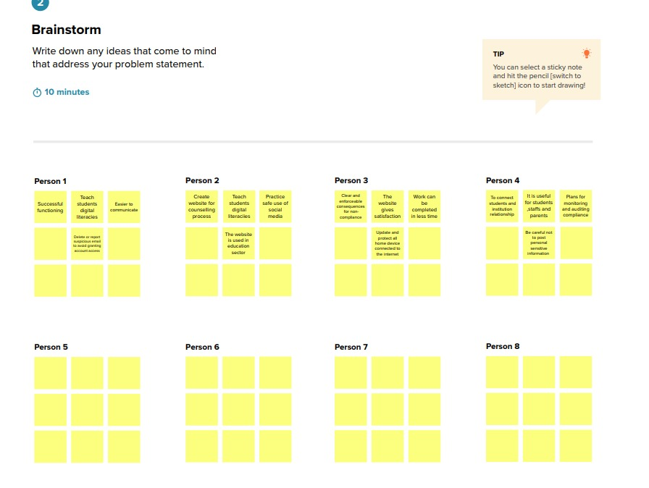

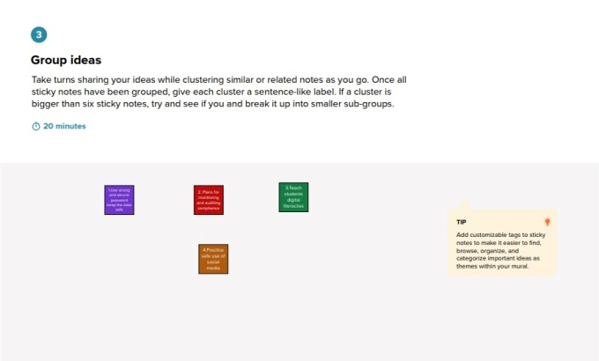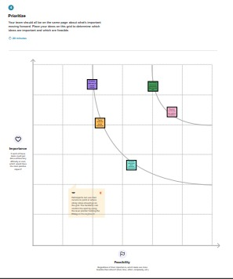

3.RESULT

3.1 Date Model:

3.2 Activity & screenshot :

|  |  |
| --- | --- |
| Object name | Field in the object |
| Recruiter | |  |  | | --- | --- | | Field label | Date type | | school | text | | students | text area | | parent | text | | collage | text | |
| Job | |  |  | | --- | --- | | Field label | Date type | | School | text | | Student | Text area | | Parent | text | |
| Candidate | |  |  | | --- | --- | | Field label | Date type | | School | text | | Student | Text area | | Parent | text | |
| Job application | |  |  | | --- | --- | | Field label | Date type | | School | text | | Student | Text area | | Parent | text | |

3.2 Activity & Screenshot:

* First we need to create new custom object that related to our topic, and type other details too.

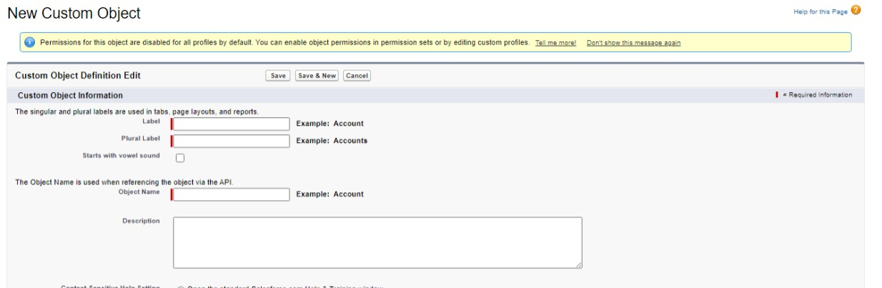

* New user should include for this session with the details.

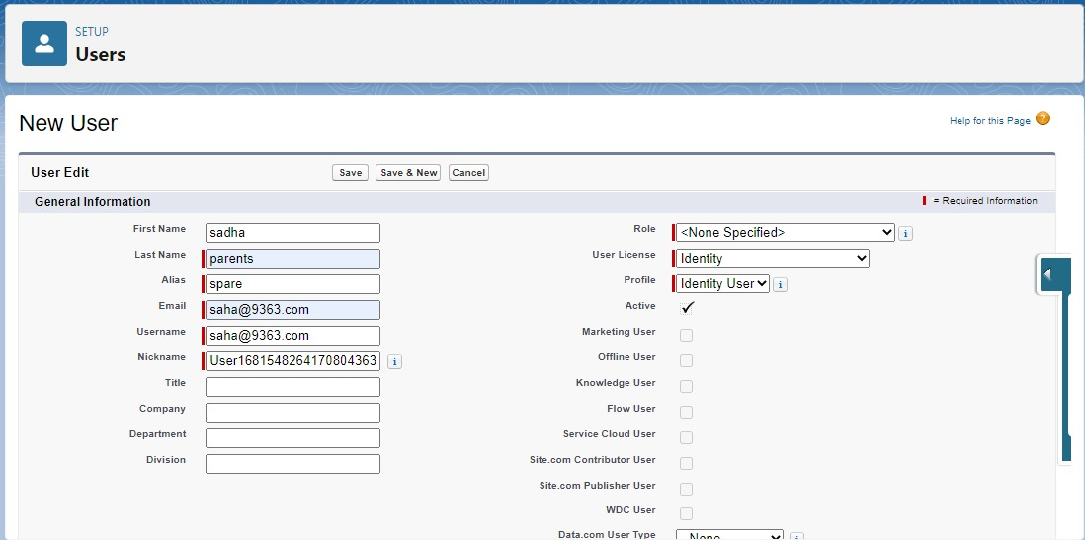

* Finally ,after completing those takes, we get the report of our project ,and dashboard too.

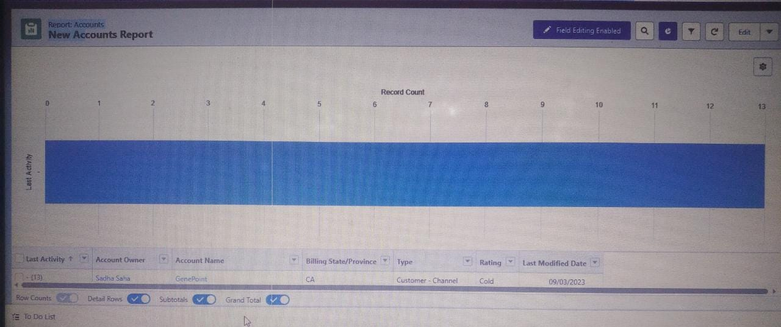

4.TRAILHEAD PROFILE PUBLIC URL

Team lead-https://trailblazer.me/id/s2020batch18

Team member 1-https://trailblazer.me/id/s2020batch19

Team member 2-https://trailblazer.me/id/sdevendran2

Team member 3-https://trailblazer.me/id/trailblazerconnect

5.disaDVANTAGES

* It allows for the consolidation of customer date and the basis for deep insights.
* It speeds up the sales conversion process.
* It increases staff productivity, lowering time-cost.
* It allows geographically dispersed team to collaborate effectively. Improves customer experience by allowing personalization and improved query resolution.

ADVANTAGES

* Having huge amounts of date on customer interaction enables an organization to build up a clearer picture of its customers.
* A lot of that paperwork could be eliminated with a CRM system.
* The CRM software also lets a business tailor its marketing communication to achieve more effective result and, hence ,a greater return on investment in sales and marketing.

6.APPLICATION

Customer relationship management (CRM) is a set of integrated ,date –driven software solution that help manage ,track, and store information related to your company’s current and potential customers .

7.ConclusiONS

It would probably be particularly difficult to develop and install customer centric strategies. A process must be gone through which would take note of CRM theory and use the experiences of other to maximize the chances of success.

* If CRM is used must be with the backing of those at the highest level and it must be planned carefully.

8.future scope

* Applications tracking system will begin to look and act more like social network.
* They are become more user-friendly.
* There is a rise in Al-based application tracking system and cloud based system.
* Application tracking software now have deep integration capabilities